VoteChain: Blockchain-Based Voting System

Abstract
Electronic voting systems have the potential to improve the efficiency, transparency, and reliability of electoral processes. However, many digital voting platforms face challenges such as data manipulation, lack of transparency and security vulnerabilities. This project presents VoteChain, a blockchain-based electronic voting system designed to ensure secure, transparent and tamper-proof elections.
The system leverages blockchain technology to store votes as immutable records, ensuring that once a vote is recorded it cannot be altered or deleted. The platform provides modules for voter registration, candidate registration, vote casting, blockchain verificationand analytics. By integrating blockchain principles with a user-friendly interface, VoteChain aims to increase trust in digital voting systems while improving efficiency and transparency in the electoral process.

1. Introduction
Voting plays a crucial role in democratic societies. Traditional voting systems, including paper ballots and centralized electronic systems, often face challenges such as fraud, manipulation, slow counting processes, and lack of transparency.
Blockchain technology provides a decentralized and secure method for recording transactions. Its characteristics such as immutability, transparency, and decentralization make it suitable for applications that require high levels of trust and security.
The VoteChain system applies blockchain principles to develop a secure voting platform that ensures election integrity and transparency.

2. Problem Statement
Traditional and centralized electronic voting systems face several critical challenges:
- Risk of vote tampering and manipulation
- Lack of transparency in vote counting
- Slow manual vote tallying
- Vulnerability to centralized system attacks
- Difficulty verifying election results
These issues can undermine public trust in election outcomes. Therefore, there is a need for a secure and transparent voting system capable of preventing fraud while ensuring voter confidentiality.

3. Aim of the Project
The aim of the VoteChain project is to develop a secure blockchain-based voting platform that ensures transparency, integrity and reliability in the voting process.

4. Objectives
The key objectives of the project include:
- To design a secure digital voting system using blockchain technology
- To prevent vote tampering and manipulation
- To ensure transparency and accountability in elections
- To prevent multiple voting by the same individual
- To provide real-time vote verification and analytics
- To create a user-friendly voting interface

5. System Overview
VoteChain is a decentralized voting system where each vote is recorded as a transaction in a blockchain ledger. Each block in the chain contains voting data that is cryptographically linked to the previous block, ensuring the integrity of the voting records.
The system provides the following functionalities:
- Voter registration
- Candidate registration
- Secure vote casting
- Vote monitoring
- Blockchain verification
- Voting analytics and result visualization
Once a vote is cast, it is stored in a blockchain block that cannot be modified, ensuring the authenticity of election results.

6. Technologies Used

Programming Languages
- Python
- Jupyter Libraries

Development Tools
- Version control using GitHub
- Interface prototyping using Figma
- streamlit

Frameworks and Libraries
- Blockchain implementation libraries
- Data visualization libraries

System Environment
- Web-based interface
- Blockchain distributed ledger

7. System Architecture
The system consists of several interconnected modules:

Voter Registration Module
This module allows administrators to register voters into the system. Each voter is assigned a unique identity to ensure that only eligible voters participate in the election.
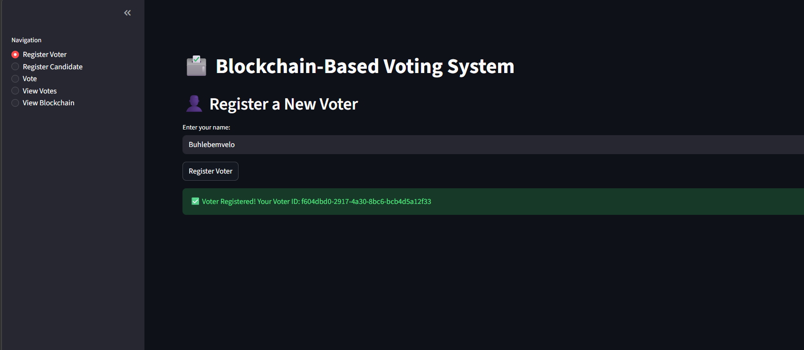

Candidate Registration Module
Candidates participating in the election are registered through this module and added to the digital ballot.
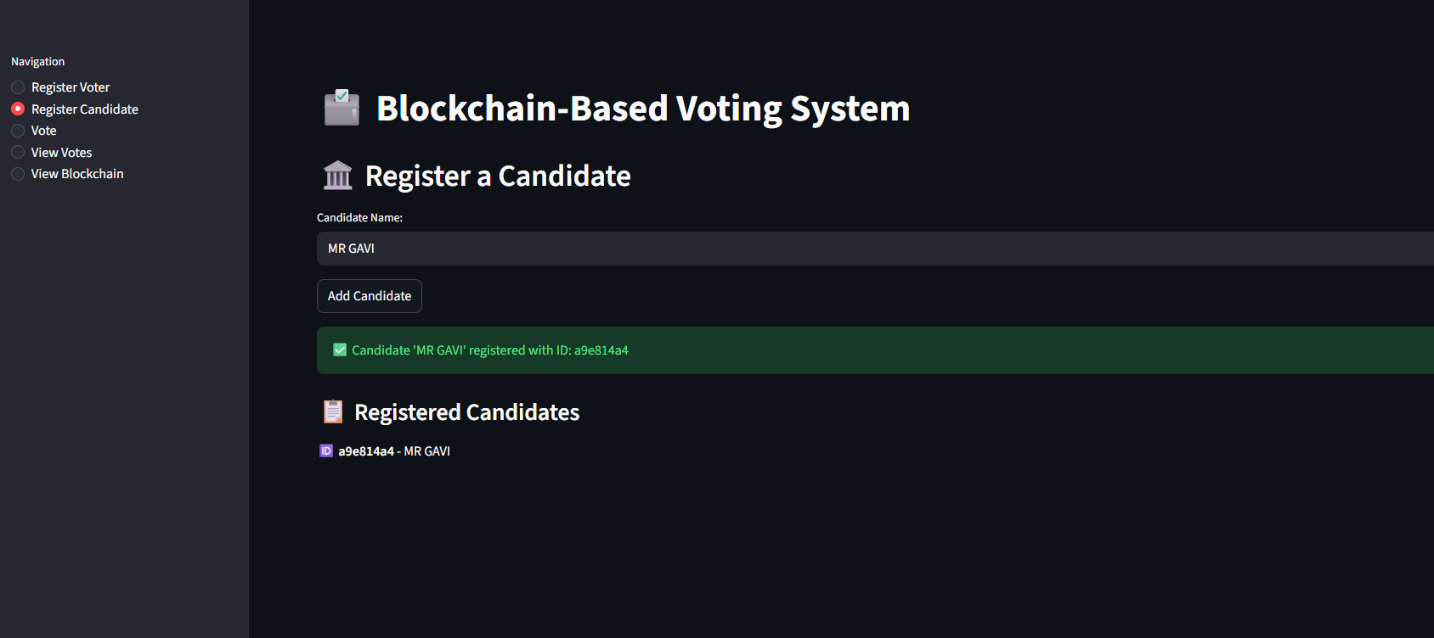

Voting Module
This module allows registered voters to cast their votes. Once a vote is submitted, it is encrypted and recorded as a transaction in the blockchain.


Blockchain Ledger
The blockchain ledger stores voting records in blocks that are cryptographically linked. Each block contains:
- Vote data
- Timestamp
- Hash value
- Previous block hash
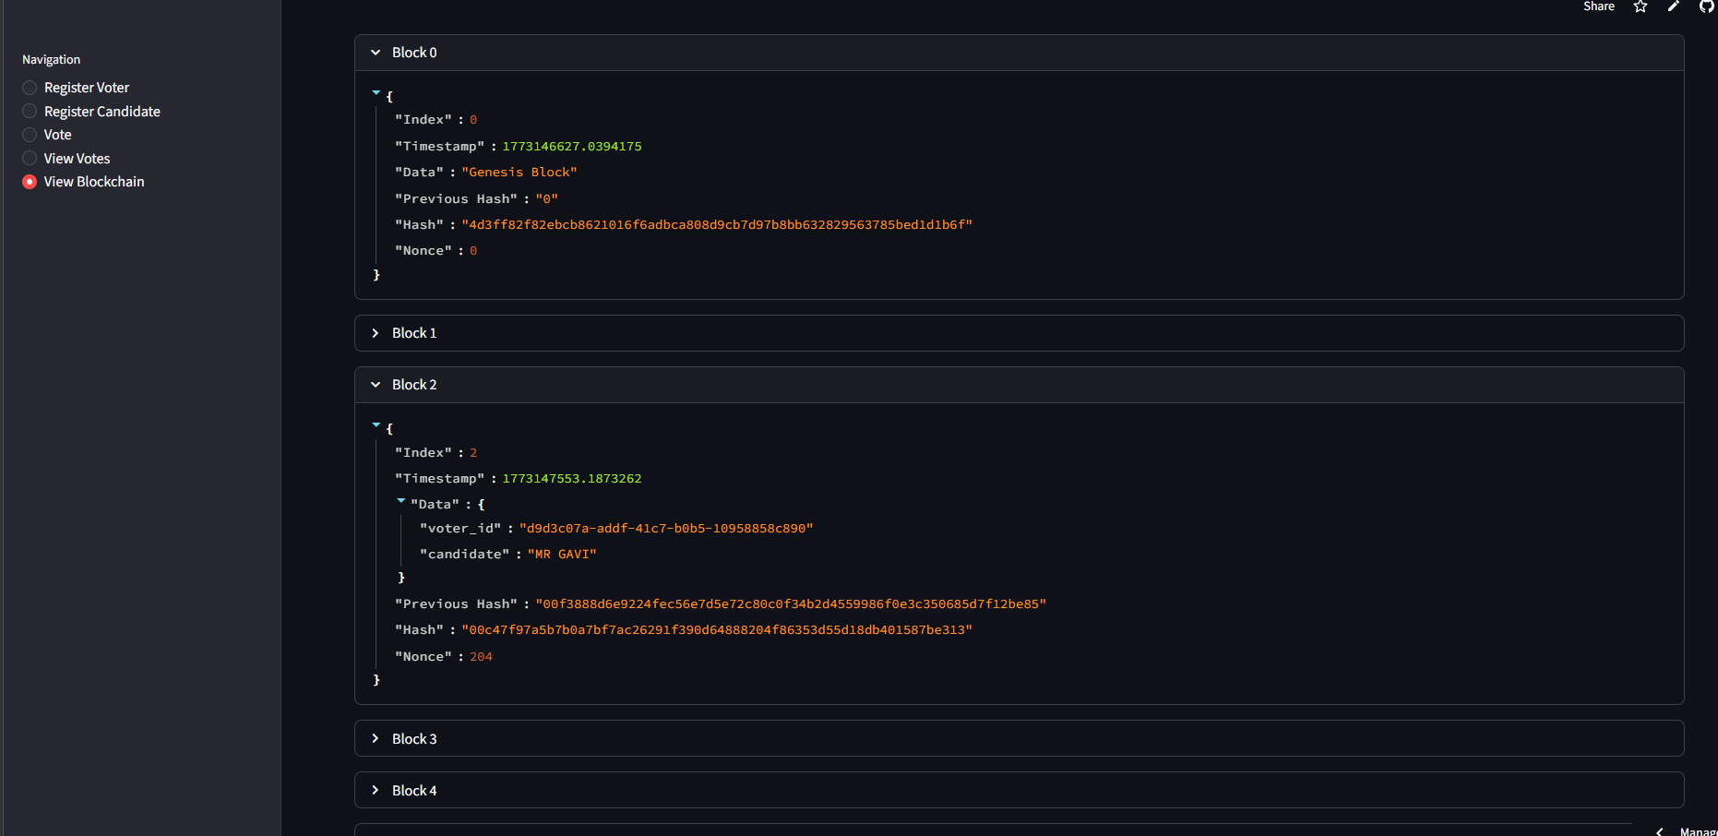
This structure ensures that the voting records remain secure and immutable.

Vote Monitoring Module
Administrators can monitor votes in real time and verify the integrity of the blockchain ledger.
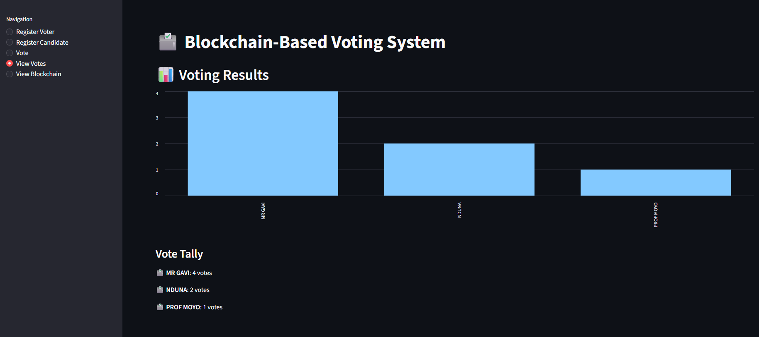

8. System Interface
The VoteChain system provides an intuitive interface that enables users to interact with the voting system easily.
The navigation menu includes the following options:
- Register Voter
- Register Candidate
- Vote
- View Votes
- View Blockchain
These features allow administrators and users to manage and participate in the election process efficiently.

9. Election Analytics
The system includes an analytics module that displays voting results and statistics.
The analytics dashboard provides:
- Total votes cast
- Vote distribution per candidate
- Election turnout statistics
- Graphical representations of results
These analytics provide insights into election outcomes while maintaining transparency.
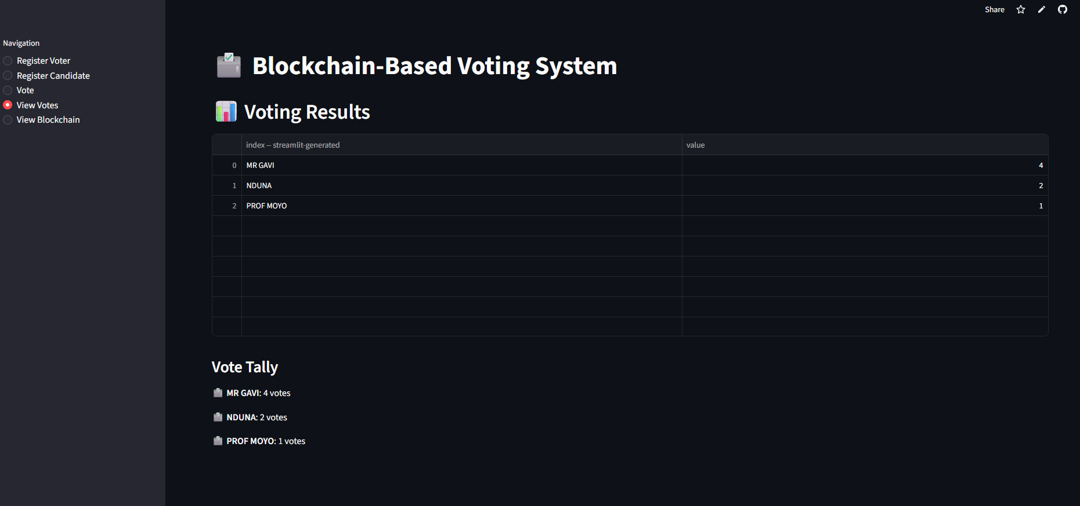

10. Advantages of the System
- Enhanced security through blockchain technology
- Transparent and verifiable voting records
- Prevention of vote tampering
- Automated vote counting
- Improved trust in election results

11. Limitations
- Requires internet access
- Technical complexity of blockchain implementation
- Requires secure identity verification systems
- Limited scalability without advanced infrastructure

12. Future Improvements
Future improvements may include:
- Biometric voter authentication
- Mobile voting applications
- Integration with national identity systems
- Enhanced blockchain scalability
- Multi-level election support

13. Conclusion
The VoteChain project demonstrates the potential of blockchain technology to improve the integrity and transparency of voting systems. By recording votes on an immutable blockchain ledger, the system ensures that election results remain secure and verifiable.
With further development and deployment, blockchain-based voting systems can significantly enhance trust in digital elections and modernize democratic processes.

